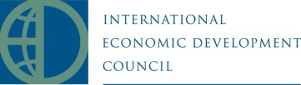
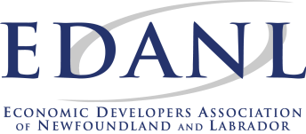
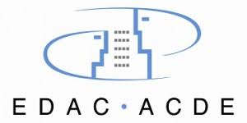
Municipality Logo Here

Enter Municipality Here
Resolution for Economic Development Week
May 6 - 11, 2019

Social Media
#EconDevWeekNL #EconDevMatters @EDANL709

Resolution
WHEREAS, the International Economic Development Council is the largest professional economic development organization of its kind and the Economic Developers Association of Canada is the national economic development organization dedicated to serving economic developers; and
WHEREAS, the Economic Developers Association of Newfoundland and Labrador is the provincial organization of economic developers pursuing excellence in the field by striving to enhance the professional competence of Economic Development Officers; to advance economic development as a distinct, recognized, and self-governing profession; and to contribute to the province's economic well-being; and
WHEREAS, Economic Developer Associations provides leadership and excellence in economic development for communities, members, and partners through conferences, training courses, best practices, awards of excellence, and initiatives such as the Certified Economic Developer designation; and
WHEREAS, the field of Economic Development is diverse and economic developers are engaged in a wide variety of settings, tailoring their approach based on the community’s needs; and
WHEREAS, economic developers work in the Municipality within the Province of Newfoundland & Labrador; and
WHEREAS, the Municipality recognizes and celebrates that economic developers promote economic well-being and quality of life for their communities by creating, retaining, and expanding jobs that facilitate growth, enhance wealth, and provide a stable tax base; and
NOW, THEREFORE, BE IT RESOLVED that the Mayor and Town Council of the Municipality do hereby—
Recognize May 6 – 11, 2019 as “National Economic Development Week” in the Municipality and remind individuals of the importance of the Economic Development field which supports community development and improving quality of life.
This ________ day of May, 2019. _________________________
Mayor of Municipality
Economic Development Week is an event created by the International Economic Development Council to celebrate the achievements of economic developers.

